Sports Ticket Classification with Logistic Regression
Short name: Bet_LogReg | L1-logistic (C=0.05, liblinear) on CLV, public %, line move, hours, stake, home, sport, market.

Problem Statement
A sportsbook blotter records whether each pre-game wager cashed (Won / Lost). The task is to build an interpretable logistic screen from market-microstructure features, name the house-edge imbalance, and evaluate with a confusion matrix plus ROC — not accuracy alone. The 12,000-row file is synthetic. This is a teaching lab, not a tipping model.

Solution Strategy
- Load sports_tickets.csv. Lost is 61.1% — a book that always fades the customer is already “accurate.”
- Dummy-encode sport and market (drop_first); y = 1 if Won. Check ranges: stake in dollars vs CLV in cents.
- Fit the lesson spec: 80/20, seed=1, LogisticRegression(C=0.05, penalty='l1', solver='liblinear').
- Read signs against desk knowledge: CLV and line-move should raise log-odds; public % should lower them.
- Alternates: scaled pipeline, L2, CLV-only card, injury/weather/live, class_weight, threshold as hold %.

Solution
Metric | Value | Metric | Value
n / cash rate | 12,000 / 38.9% | Test accuracy | 0.627
Confusion (t=0.5) | 1305 146 / 749 200 | Won prec / recall | 0.58 / 0.21
ROC AUC | 0.633 | L1 zeros / intercept | 3 of 12 / +0.21
Lift over the Lost baseline (0.611) is about 1.6 accuracy points. line_move and clv_cents lead the positive side; public_pct is negative. Adding injury_star (β ≈ −0.50) edges AUC to ~0.64.
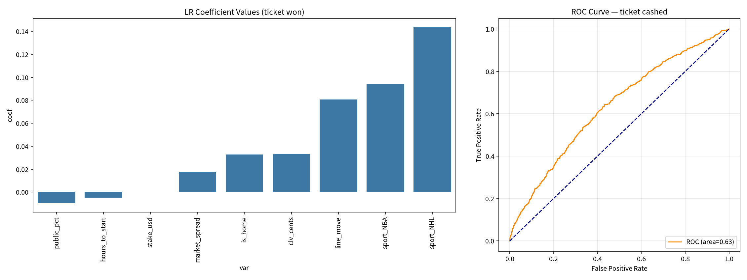
Left: L1 coefficients (zeros dropped). Right: hold-out ROC. t=0.30 raises Won-recall to 0.87 and floods false alarms; t=0.60 is a tiny high-precision hold list.

Key Takeaways
- Accuracy 63% next to a 61% house baseline is a rounding error unless you also show AUC and recall.
- CLV is the sharp signature — and it is only known after the close. Using it as a pre-game feature is leakage.
- A high threshold is a hold/limit policy; a low threshold is a marketing blast. Do not ship the latter.
- Good fit: blotter screens, juice education, threshold workshops. Not a fit: live picks, Kelly sizing, targeting losing customers.
- Not betting advice. Synthetic book. 18+ only in any real-world counterpart.

